**Data Structures and Algorithms**

**Lab report: 1**

|  |  |
| --- | --- |
| **Name:** | **Ali Salman** |
| **Reg no:** | **FA21-BCE-093** |
| **Class:** | **BCE-3A** |
| **Lab Instructor:** | **Dr. Ali Mustafa** |

**Lab 01**

**Revision of programming concepts of C language**

**In-Lab Task 2:**

**Program:**

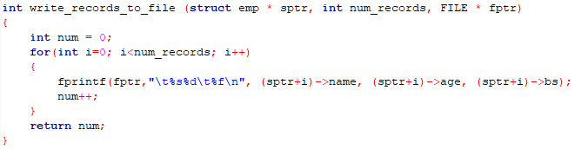

**In-Lab Task 3:**

**Program:**

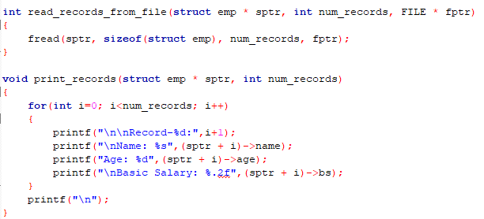

**Post-Lab Task:**

**Program:**

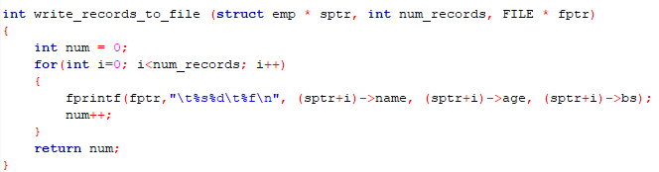

**Critical Analysis:**

This lab covers the definition and declaration of structures in C. The explanations provided are clear and concise, making it easy for participants to understand the concept. The lab exercises allow for hands-on practice, ensuring that students are proficient in using structures.

The lab's treatment of pointers in C is particularly commendable. It offers a thorough review of pointer concepts and demonstrates how they can be used effectively with structures. The practical exercises provide ample opportunities to work with pointers, reinforcing their understanding.

One of the highlights of this lab is its emphasis on file handling. Students learn how to read from and write to files using structure arrays. This real-world application of programming skills is invaluable for preparing students for practical programming tasks. The lab exercises in this section are well-structured and progressively challenging.